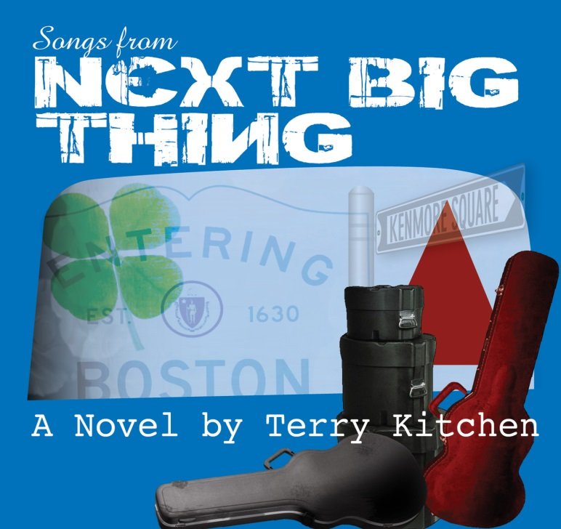
Terry Kitchen
urban campfire productions
617-833-0631
info@terrykitchen.com
www.terrykitchen.com
www.facebook.com/NextBigThingNovel

Songs from Next Big Thing
is the companion CD to Terry Kitchen’s debut novel, published in September 2013 by Urban Campfire Press. Set in the ’80s Boston music scene, Next Big Thing tells the story of a band grappling with the fact that making it big might not be quite as easy as it seemed.
As Kitchen relates, “Since it’s about a band, there’s lots of music in the book. The main character (one Mark Zodiac) is a songwriter, so I thought it might be fun to ‘write along with Mark.’ I’d start typing a scene, then stop and pick up my guitar…it made the whole process very inefficient. Plus I have about another album’s worth of songs from scenes I cut.”
The resulting “songtrack” CD is an eclectic mix of Terry’s singer/songwriter leanings and ’80s rock influences, including a couple vintage tracks from Terry’s ’80s band Loose Ties (such as the aptly-titled “Get Out of My Novel”). Also included is the poignant “Ghosts of Kenmore Square,” about the demise the legendary Rathskeller nightclub.
The CD is included with copies of the novel ordered directly from www.terrykitchen.com, and is sold separately by Amazon and CDBaby. All copies of the book and Ebook come with a free soundtrack download code.

Track notes:

1. Killing Time Terry Kitchen 3:52

A “plugged” update on Terry’s acoustic chestnut “The Favor,” with harmony vocals from Mara Levine. The last song Mark Zodiac writes before leaving Ohio for Boston.

2. Animal to Animal Shadowland 3:00

“Shadowland,” the fictional band from Next Big Thing, writes this during a basement jam session. “Imagine it on the radio in 1982, between Adam Ant’s ‘Goody Two Shoes’ and Bow Wow Wow’s ‘I Want Candy.’” In fact Kitchen is extremely upset with himself for not writing this in 1982, when it might have done his real band some good.

3. Dogtown Rain Terry Kitchen 3:42

Dogtown is an abandoned Colonial-era settlement in the middle of Cape Ann, now covered in briar patches. “The month we moved to Rockport, it rained every day. What happened to Dogtown? I think they drowned.” Brian Middleton does the harmony vocal.
Terry Kitchen Songs from Next Big Thing

Track notes (continued):

4. Second Glance Terry Kitchen 4:48

An “unplugged” version of this reggae-grooved track from Loose Ties’ 1985 vinyl EP. With Brice Buchanan on lead guitar and vocal harmony.

5. Same Heart Twice Rebecca Lynch with Terry Kitchen 4:15

“Rebecca and I sang together at Occidental College in LA (where a certain Barry Obama was also in attendance) and we recently discovered we were both in Boston. Good thing, too, since her smoke-and-honey style is perfect for this blues tune.” Terry’s own vocal version is on his Summer to Snowflakes CD.

6. Shy Girl (Kat’s Song) Terry Kitchen 2:27

The guitar-and-bongos-driven love theme from Next Big Thing. In retrospect, Terry realizes he may have overshot the ’80s and landed somewhere in the vicinity of Beatles ’65.

7. Take a Ride (funk mix) Loose Ties 4:26

For better or for worse, what the ’80s actually sounded like. Terry’s ’80s band Loose Ties, as captured in 1984 by Kearney Kirby (of November Group). Vocal by Ties’ bassist Bill Kuhlman.

8. Just Like Where the River Meets the Sea Terry Kitchen 3:00

The other love theme from Next Big Thing, which gives you some idea of the plot. Kitchen overshoots the ’80s again and lands this piano ballad somewhere between Captain Fantastic and the Brown Dirt Cowboy and “Bridge Over Troubled Water.” Drums by Larry Finn.

9. Get Out of My Novel Loose Ties 4:22

This 1988 track was Loose Ties’ swan song, in that they’d officially broken up in 1987. Kitchen likes the anarchy in the fade out ‒ an encouraging sign that rock was waking up from its ’80s synth-pop torpor. Piano and sax by honorary Tie Barry “B-wah” Singer, and harmony by “Voice of the Red Sox” Leslie Sterling.

10. Ghosts of Kenmore Square Terry Kitchen 3:58

There’s a moving description of the Rat’s final hours in Brett Milano’s The Sound of Our Town: A History of Boston Rock. Says Kitchen: “I imagined all us Ratsters still wandering the square, like the spirits in Poltergeist.” Deirdre Bergeron on harmony, and Brice Buchanan on harmony and throb guitar.

All songs by Terry Kitchen.
Produced by Tom Ruddgren.
Full credits at www.terrykitchen.com

